 | 

Master’s Thesis

Technische Hochschule Deggendorf
Fakultät Elektro- und Medientechnik
Studiengang Elektro- und Informationstechnik

Übergang zwischen öffentlichem Netz und Mikronetz mit Energiespeichersystem
Elektrisches Design und Software-Implementierung in OpenEMS

Transition between public grid and microgrid with energy storage system
Electrical design and software implementation in OpenEMS

To obtain the academic degree:
Master of Science (M.Sc.)

Submitted by:
Supervisor:
Hüseyin Sahutoglu
Prof. Dr.-Ing. Otto Kreutzer

Deggendorf, den 28.02.2021

Eidesstattliche Erklärung
Name des Studierenden: Hüseyin Sahutoglu
Name des Betreuers: Prof. Dr.-Ing. Otto Kreutzer
Thema der Masterarbeit: Micro Transition between public grid and microgrid with energy storage system, Electrical design, and software implementation in OpenEMS

- Ich erkläre hiermit, dass ich die Bachelorarbeit selbstständig verfasst, noch nicht anderweitig für Prüfungszwecke vorgelegt, keine anderen als die angegebenen Quellen oder Hilfsmittel benutzt sowie wörtliche und sinngemäße Zitate als solche gekennzeichnet habe.
Deggendorf, den 30.10.2020 Unterschrift d. Studierenden: __________________________

- Ich bin damit einverstanden, dass die von mir angefertigte Bachelorarbeit über die Bibliothek der Hochschule einer breiteren Öffentlichkeit zugänglich gemacht wird.
☐ Ja ☒ Nein
Ich erkläre und stehe dafür ein, dass ich alleiniger Inhaber aller Rechte an der Bachelorarbeit, einschließlich des Verfügungsrechts über Vorlagen an beigefügten Abbildungen, Plänen o.ä. bin und durch deren öffentliche Zugänglichmachung weder Rechte und Ansprüche Dritter noch gesetzliche Bestimmungen verletzt werden.
Deggendorf, den 30.10.2020 Unterschrift d. Studierenden: __________________________

Bei Einverständnis des Verfassers mit einer Zugänglichmachung der Bachelorarbeit vom Betreuer auszufüllen:

- Eine Aufnahme eines Exemplars der Bachelorarbeit in den Bestand der Bibliothek und die Ausleihe des Exemplars wird
☐ befürwortet ☐ nicht befürwortet
Deggendorf, den 30.10.2020 Unterschrift d. Betreuenden: __________________________

Contents
I. Eidesstattliche Erklärung II
II. Abbreviations 3
1 Introduction and Motivation 4
1.1 The Company FENECON GmbH 4
1.2 Objectives 6
2 Data Collection 7
2.1 Characteristic parameters of a storage system 7
2.1.1 Capacity 7
2.1.2 State of Charge 8
2.1.3 State of Health 10
2.1.4 The C-Rate 11
2.2 Battery Management System 11
2.2.1 Introduction to OpenEMS 12
2.3 The Modbus-Protocol 13
2.3.1 Modbus RTU 13
2.3.2 Modbus TCP 14
2.4 Grid connection status detection 14
2.5 Inverter topologies 15
2.5.1 Three phase three wire 15
2.5.2 Three phase four wire 15
2.6 Inverter operation mode in On-Grid and Off-Grid situation 15
2.6.1 Current Source operation 15
2.6.2 Voltage Source Operation Mode 15
2.7 Summary 15
3 State of the Art 15
4 Hardware and Software design 15
4.1 Components Used 15
4.1.1 Stationary storage system 15
4.1.2 The inverter 17
4.1.3 The FEMS 18
4.1.4 Evaluation of suitable switching devices 19
4.2 Circuit design 19
4.3 Software implementation 19
4.3.1 Software architecture 19
4.3.1.1 Terminology 20
4.3.1.1.1 OpenEMS Component 20
4.3.1.1.2 Channel 21
4.3.1.1.3 Channel Address 22
4.3.1.1.4 Nature 22
4.3.1.2 Architecture 22
4.3.1.2.1 Input-Process-Output 23
4.3.1.2.2 Cycle 24
4.3.1.2.3 Controller 24
4.3.1.2.4 Scheduler 25
4.3.1.2.5 Fault Tolerance 26
4.3.1.2.6 Adaptive User Interface 27
4.3.1.2.7 Apache Felix Web Console 29
4.3.1.3 //TODO Reading and writing of the registers 30
4.3.1.3.1 Software implementation 30
4.3.1.4 //TODO Implementation of the inverter in OpenEMS 30
4.3.1.5 //TODO Important methods for controlling the inverter 30
4.3.1.6 //TODO Establishment of data monitoring 30
4.3.1.6.1 //TODO Load and run the OpenEMS on the FEMS 30
4.3.1.6.2 //TODO Basic Apache Felix web console configurations 30
4.3.1.6.3 // TODO Configuration for the OpenEMS backend and OpenEMS UI 30
4.3.1.6.4 //TODO Other controller configurations 30
5 Evaluation and test 31
6 Summary / conclusion / outlook 31
6.1 //TODO Interpretation of the measurement results 31
6.2 //TODO Current limitation at the state of charge limits, cell voltages? 31
6.3 //TODO Balancing Symmetric Controller ? 31
7 References 31
Appendix A FEMS hardware specifiations 32

List of Figures
Figure 1 7
Figure 2 9

Abbreviations
Abkürzung | Erklärung
BMS | Batteriemanagementsystem
BYD | Build Your Dreams
DC | Direct Current /  Gleichstrom
FEMS | FENECON Energie Management System
MPP | Maximum Power Point
PV | Photovoltaic
SoC | State of Charge /  Ladezustand
STC | Standard Test Conditions /  Standardtestbedingungen

Introduction and Motivation
It has continuously contributed to the development of sustainable energy sources, including nuclear energy, global warming reduction, limitations, extreme urban weather conditions and air quality changes due to fossil fuel carbon emissions. A global energy change needs to take place when it comes to providing living space for humans and animals in a sustainable way. These and many other issues need as quickly as possible a 100 percent return of oil, which will have to occur sooner or later due to the limited supply of fossil fuels and resources. Therefore, expansion of PV and wind farms is necessary. Due to the reduced feed-in tariff for PV generated electricity, it is becoming more and more interesting and profitable for private PV system operators to consume electricity generated by their systems on site. This aim can be accomplished using energy storage in grid-connected photovoltaic systems and a significant contribution can be made to a decentralized energy supply by feeding the grid with surplus energy. Decentralized energy storage systems can help offset the surplus and loss of energy produced by renewable energy producers to some degree. With smart control software, energy storage systems can provide network services. For companies already operating a PV system, a fixed storage facility may pay for itself within ten years. With the assistance of the energy storage device, this is only feasible, as the control software avoids power peaks and therefore does not exceed the limit of a more expensive power connection. This is only one of the computers features for fixed storage.
The FENECON Commercial Industrial battery energy storage systems are now mainly used for on-grid applications. As a next step the system should be upgraded by a back-up solution which fits the need of customers for switching from public grid to microgrid and vice versa. Designing off-grid battery storage systems requires additional hardware and software components to enable a safe grid disconnection of public grids and provide functions like black-start capabilities.
This project is focusing on the concept engineering and technical implementation of a suitable hardware and software system, targeting a serial production ready as extension to the existing technical units, the FENECON Battery Energy Storage Systems.

The Company FENECON GmbH
Climate change is a constantly controversial issue in politics and business. The origin of this is the constant warming of the earth. One possibility to counteract this choice is a one hundred percent energy transition. The focus of their implementation is on the environmentally friendly generation and use of energy. This is a goal that should be achieved soon in order not to cause irreversible damage to the climate. With this motto, Feilmeier New Energy Consulting (FENECON) was founded in 2011. FENECON sees great potential in energy storage systems, which should also satisfy the dream of self-sufficiency in-house energy. Intelligent storage solutions have always been proven by the young company with all kinds of end-customers. The customer base ranges from private households to specialized wholesalers and energy suppliers. To pave the way for a clean future, the company has long-term partnerships with innovative energy generation, virtual power plants and industry coupling companies. The FENECON team continues to pursue this goal today. As a result, the company has developed the following five main pillars on which storage systems are based:
- PV Self-Consumption: With the help of a PV system, electrical energy is stored in the electricity storage system during the day and is consumed overnight. The use of a memory stops the electrical meter, which in turn means that no electricity is drawn from the grid.
- Active energy management: with active energy management, additional components such as heat pumps and heating rods are used optimally to make stored energy available to consumers efficiently. This reduces the high cost of electricity and the high load peaks.
- Security: an emergency power grid can be made available by extending the photovoltaic system with a power storage unit. For each individual user, the requirements for emergency power are different. FENECON offers special solutions for security requirements from uninterrupted power supplies to island capacity for agriculture, trade, or households.
- Grid services: due to the unpredictable influence of weather conditions, the generation of electricity from renewable energy sources, such as solar and wind, cannot be constant. That is why the need for grid stabilization measures increases the further progress of the energy transition. FENECON Power Storage Systems have been specifically designed to provide fast response times and high output power. Storage systems can therefore support the network operator, for example through primary control power, in stabilizing the frequency of the network.
- Participation in the market: In contrast to private customers and small businesses, bulk purchasers are billed based on connected loads and peak loads. Storage systems with high input and output power can reduce peak loads and recharging the storage system at a negative electricity price.
It consists of the battery modules and the BMS (Battery Management System) which are mounted in the rack. The inverter is purchased from outside companies to remain versatile with the desired efficiency. Both the storage system and the inverter are managed simultaneously by the OpenEMS program. It is open to all via the Internet and is extended and enhanced on a regular basis by FENECON. In addition to storage systems, the company sells PV systems, e-mobility with the storage system division being the main business of FENECON.
- Photovoltaic: Projecting and selling photovoltaic systems (PV) promotes the goal of providing 100% environmentally friendly and cheap electricity.
- E-mobility:
  - DC charger, IES-KEYWATT
  - AC charger, KEBA, Hardybarth
  - Fenecon offer 1 management for 1 charger to be able to charge with access power which depends on the user input, management for multi-charge points to distribute the max available power of each grid connection points.

Objectives
The purpose of the present work is to design off-grid battery storage systems with additional hardware and software components to enable a safe grid disconnection of public grids and provide functions like black-start capabilities. In order to expand the portfolio of FENECON, a development basis for the Commercial 30/30 energy storage system is developed. In the end, it can be used in small companies, farms and agricultural areas. FENECON describes the inverter, the electrical storage, the OpenEMS program for controlling the energy storage device and its hardware. Elementary parameters of the electrical storage device must be provided at the beginning of the job. In addition, an grid detection method is required to accompany the implementation of the storage system. The communication interface, which links the individual components to the energy storage device, must be presented. The concept for designing a storage system is discussed in the following sections. The individual components of the energy storage system are presented, and an analysis approach is used. A test report is then drawn up, which tests the operation of the energy storage device and sets the requirements for the Commercial Product Line. After the measurement setup or hardware configuration has been displayed, the inverter must be mounted in OpenEMS, the FENECON control program, in the next chapter. The data generated by the device is then stored centrally, where it can be called back. When all the arrangements have been made, the measurement is carried out and suggestions are made that lead to quality assurance. The company FENECON is presented at the beginning.

Data Collection
In this chapter, to understand the system in more detail the most important parameters of a stationary storage system are presented at the beginning. Furthermore, grid detection methods to analyse what kind of device will be needed to detect the grid connection status and for development of a product are presented, which are mainly used in industry and are relevant for this thesis. Then the OpenEMS and its communication interfaces will be explained by the company FENECON, as it plays a central role in this thesis.

Characteristic parameters of a storage system
The presentation of the parameters of the storage system starts at this stage. They define and differentiate stationary storage systems. In addition, they are important for the understanding of the storage system. A storage system is a lithium-ion-based electrical storage system with an inverter that is powered by an energy management system. The following chapter defines and illustrates the electrical capacity.

Capacity
In general, the capacity of the electrical storage device defines the amount of charge that can be contained in the storage cells. The SI unit for the sum of the charge is given in Ah. Multiplied by the nominal voltage U_{N} results in the W_{h} unit, with a definition of the electricity. An additional definition of the energy in the cell is the energy that relates to the mass of the cell (W_{h}/g) and the energy density that relates to the volume (W_{h}/m³). There is also a distinction made between various types of capacity.
The maximum power of the C_{max} that can be drawn is the amount of charge that can be provided by a fully charged battery. When the battery comes out of output, the C_{max} capacity is equivalent to the C_{N} nominal capacity [2]. Full capacity declines only through the ageing of the calendar and the number of charging and discharging periods. With the removable power C, the volume of charge is released from the battery at any current and temperature value chosen until the final discharge voltage is reached [2]. The C_{N} nominal capacity of the battery defines the capacity specified under nominal conditions [2]. The nominal condition defines the nominal IN current and the nominal T_{N} temperature and can therefore no longer be chosen arbitrarily. Capacity loss describes the actions when the battery can accept or releasing a smaller volume of charge due to ageing. The ageing status is defined by the "State of Health" (SOH) parameter and given in percent, in which the ageing of the calendar and the number of cycles have an effect. The following figure clearly demonstrates the functions of the types of capability.
Figure 1
For the memory to reach a long service life and thus a high number of cycles, the cells are not charged or discharged within the limits. For this reason, the "Depth of Discharge" parameter, which is designed to ensure a long service life for lithium-ion-based storage cells, is presented. It defines the ratio of nominal capacity C to maximum usable capacity C_{max}, which is expressed in percent. In the case of a stationary storage facility, the upper and lower capacity limits of the nominal capacity are not reached to ensure sustainable service. For the energy storage system consumer to be able to estimate the current power, the SOC parameter is provided in the following chapter.

State of Charge
The "State of Charge" defines the current charging condition of the battery and is given as a percentage. As a result, a fully charged battery has a SOC of 100 percent. The SOC value can, in theory, be determined using the formula:
$SOC=\frac{C}{Cmax}*100$ (2.1)
Since equation 2.1 does not consider the SOC value in the past or the time factor, it is not reliable for the battery. Because the SOC value indirectly has the task of protecting the battery from possible deep discharge and from overcharging. The following three approaches have emerged to assess this value reliably:
Coulomb-Counting Methode
The calculated current is combined with this approach over time. To prevent an offset error, the amount of charge SOC₀ already present must also be identified.
$SOC={SOC}_{0}+ \frac{1}{C_{N}} \int_{t_{o}}^{t_{0+t}}{I_{DC}dτ}$ (2.2)
There is little computational effort due to the simplicity of the algorithm. This is a great benefit of the Coulomb system of counting. There is, however, an integration flaw since it does not take self-discharge into account. Periodic calibration steps are required to compensate for the error [3]. These steps can be applied, for example, during the resting-tension process.
Measurement of the Open-Circuit-Voltage
Another way to calculate the SOC value is by calculating the open circuit voltage (OCV) of the battery. It represents the charging status of the battery and an algorithm is used to assess the charging status. Since the open circuit voltage and the SOC value are almost linear in relation to each other, this method works. With the following equations, the open-circuit voltage or the charging status can be calculated very easily.
$U_{ocv} = U_{100}*SOC\left(t\right)+ U_{0}$ (2.3)
$SOC\left(t\right)= \frac{U_{ocv}\left(t\right)- U_{0}}{U_{100}}$ (2.4)
$U_{ocv}\left(t\right)$ defines the open-circuit voltage of the battery, SOC$\left(t\right)$ represents the state of charge in percent, U0 is the open-circuit voltage at SOC = 0 percent, and U₁₀₀ is also the voltage at SOC = 100 percent. For this approach, the very simple determination of values is beneficial. However, to achieve a reproducible result, the load must be decoupled while calculating the non-load voltage. Therefore, this approach does not operate during the process. Further drawbacks are that the ambient temperature is not taken into account and that the relationship between the open circuit voltage and the SOC at the charging limits is extremely non-linear. Figure 2 shows the non-linearity of the boundaries.
Figure 2
The SOH value is another important parameter. It describes the current quality of the cells that essentially determine the power. The presentation will take place in the following segment.

State of Health
Due to various aging effects, the cells and therefore the battery lose their power. One consequence is that the chemical reactions in the cells increase when the ambient temperature is high. This lead, in turn, to a loss of capacity. In addition, internal resistance increases and thus decreases performance [5]. This loss of capacity can be represented using the State of Health (SOH) which is determined from the C_{max} maximum capacity quotient and the C_{N} nominal capacity.
$SOH = \frac{C_{max}}{C_{N}}*100$ (2.5)
SOH is given in percent, with 100 percent being a new battery and 60 percent being an unusable battery due to a high safety risk. Electrical car batteries are rejected at a SOH value of 80 per cent because they no longer maintain the range of the car [2]. In addition to the SOH value, the C rate is a fixed parameter. This is set out in the following section.

The C-Rate
With the C-rate, charging and discharging currents are given in uniform form to make batteries of different capacities comparable. It represents the time it takes until, for example, the battery is discharged. Essentially, the C-rate is formed from the quotient of power and energy or current and the sum of charge. The resulting SI unit shall be $1/h$.
$C = \frac{P_{DC}}{E_{N}} = \frac{I_{dc}}{C_{N}}$ (2.6)
In general, the C rate is given in percent or the estimated factor n is given as C (i.e., $\frac{1}{2}$C; 1C; 2C; etc.). For example, for a battery with a nominal capacity of $C_{N} =10 Ah$ and a rate of C of 0,5 C, the current $I_{DC}=5 A$. To maximize the service life of stationary storage systems, no C-rate of more than 100 per cent is achieved. They are always possible. This precaution increases the service life of the cells, as the chemical reactions to charge separation inside the cells proceed more slowly and thus create less waste heat. With this measure, the SOH value is lowered more slowly. The parameters presented are controlled by the battery management system. This part will be introduced next.

Battery Management System
The battery management system (BMS) plays a key role in the use of lithium-ion batteries. On the one hand, the BMS must record or partially calculate the calculated values of the cells and, on the other hand, track the state of charge. It must also process and respond to the data received. With the aid of this part, the battery is guaranteed to work permanently and thus safely. The BMS transforms reported data from cells to cell differential voltage and cell differential temperature. The cell difference voltage U_{diff} is determined from the following:
$U_{diff} = U_{z,max}- U_{z,min}$ (2.7)
U_{z}, max, represents the maximum cell voltage and U_{z}, minus the minimum cell voltage. The cell difference temperature T_{diff} is determined as follows:
$T_{diff} = T_{z,max}- T_{z,min}$ (2.8)
They provide details as to whether the cells are charged or discharged equally. The general rule is that the difference values are also small at a low C-rate. The BMS also includes the present SOC value, the SOH value, and the nominal voltage. The BMS will turn off the battery if the voltage limit or the amount of charge is exceeded or lowered in order to protect it from potential damage. It warns in this regard, decreases the loading, and discharge current and, for safety reasons, turns the system off by opening the DC relays. The fundamentals of a stationary storage device are understood from this experience. The methods of study for controlling a stationary storage device can now be discussed in the following subsection.

Introduction to OpenEMS
OpenEMS is a modular energy management application. It has been developed taking into account the requirements for monitoring, controlling and integrating energy storage systems along with renewable energy sources and complementary equipment and services such as electric vehicle charging stations, heat pumps, electrolysers, service life electricity tariffs and more. It is used to monitor the components of the energy storage device and is located locally at the stationary storage facility. This is a definition of the OpenEMS Edge. Depending on the configuration of the energy storage device components implemented, algorithms can be implemented in the OpenEMS Edge.
- which optimizes self-consumption,
- finds the cheap electricity tariff,
- integrates the producers (e.g., PV system),
- integrates controllable consumers (e.g., e-cars) and
- provides network stabilization and peak shaving services.
The collected data is encrypted and sent over the Internet to the OpenEMS backend running on the server. This enables FENENCON employees to perform on-line maintenance and monitoring of individual energy storage systems. OpenEMS is rounded off by the OpenEMS UI. This means the user interface, i.e., the user interface in the browser or smartphone, which displays data from the energy storage system in a user-friendly manner in real time. The implementation of the component generally deals with the reading of the component registers and, with the help of the algorithms implemented, makes the decision, for example, to stop charging or unloading the battery so that it does not result in overloading or deep discharge. Modbus RTU and Modbus TCP have already been implemented in OpenEMS. The following subsection introduces the Modbus protocol and its interfaces for communication.

The Modbus-Protocol
The Modbus protocol was developed in 1979 by Modicon (Schneider) based on a master/slave structure [8]. With this protocol, a master can interact with a few slaves. The master initiates contact, and the slaves respond in response. In addition, the Modbus protocol uses functional codes to ensure supervised communication. The table in Appendix X, Table X offers a simple description of all the Modbus protocol feature codes. The feature codes used must be issued by the manufacturer for communication with the system. Communication paths for Modbus RTU and Modbus TCP are also available. These are explained in more detail in the sections below. The Modbus protocol was developed in 1979 by Modicon (Schneider) based on a master/slave structure [8]. With this protocol, a master can interact with a few slaves. The master initiates contact, and the slaves respond in response. In addition, the Modbus protocol uses functional codes to ensure supervised communication. The table in Appendix A.1, Table 9 offers a simple description of all the Modbus protocol feature codes. The feature codes used must be issued by the manufacturer for communication with the system. Communication paths for Modbus RTU and Modbus TCP are also available. These are explained in more detail in the sections below.

Modbus RTU
The acronym RTU stands for Remote Terminal Unit and defines data traffic on a serial bus. With a serial bus, the bits are transmitted one by one in the form of telegrams. Popular serial bus systems are RS-232 or RS-485, for example. The data is unipolar with RS-232 and differential with RS-485.
Start | Address | Function | Data | CRC | End
3.5 Char time | 8 Bit | 8 Bit | N * 8 Bit | 16 Bit | 3.5 Char time
Figure 3 Modbus RTU typical message frame [1]
There is a delay of at least 3.5 characters between frames, each character being 8 bits long. This is accompanied by a system slave ID to ensure a specific assignment. The communication partners know, through the function code, what the objective of the system should be. The data area contains the actual details of the users.

Modbus TCP
This version is subject to the Modbus protocol and the Transmission Control Protocol (TCP/IP) protocol. The data is thus distributed in the form of packets. The network participants are identified via IPv4 addresses. Port 502 is reserved for communication via Modbus TCP.
MBAP Header | Function | Data
7 Byte | 1 Byte | N * Byte
Figure 4 Modbus TCP typcial message frame [1]
As with Modbus RTU, in addition to the data, the function codes are given through functions. The Modbus Application Protocol Header (MBAP) is also included in the Modbus TCP framework. A further breakdown of the MBAP header is shown in.
Transaction ID | Protocol | Length | Unit ID
2 Byte | 2 Byte | 2 Byte | 1 Byte
Figure 5 Structure of the MBAP header [1]
The transaction ties with the respective participant are passed to the transaction ID. The requested participant shall respond with the same transaction ID. The protocol type is transmitted with the protocol ID. This is zero with Modbus. The length of the data would then be transmitted to the contact partner. Unit ID shall be set to one for direct contact with the Participant, as the address is made with the IP address. Modbus TCP has various topologies, with the star topology being the most widely used switch.

Grid connection status detection

Inverter topologies

Three phase three wire

Three phase four wire

Inverter operation mode in On-Grid and Off-Grid situation

Current Source operation

Voltage Source Operation Mode

Summary

State of the Art
// TODO Literature review

Hardware and Software design

Components Used

Stationary storage system
The electrical storage of the battery from Soltaro is used as an electrical storage medium. It is fitted with 10 memory modules and a battery management system. The storage capacity of the module is 90 Ah. Multiplied by a nominal voltage of 38.4 V of the module, this results in a nominal voltage of 3.456 kWh. The total nominal voltage for this configuration is therefore 34,56 kWh, as the storage modules are connected in series. The storage module contains 12 cells which are controlled for voltage and temperature. The cells are lithium-iron phosphate cells with a specific capacity of 100 to 150 mAh/g. The data for voltage and temperature monitoring shall be transmitted to the BMS via the RS-485 bus. The daisy chain topology is used and terminated with a 120 Ω resistor. Figure 3 demonstrates the wiring on the storage system. The blue lines symbolize the power links and the dotted lines of the RS-485 bus. In addition to power and communication links, the BMS module has a main switch and an electrical start switch. They can be used to enable and disable the storage system. The term BMU defines the memory module or the BMS. With the interface of the Battery Control Unit, cascading with the same storage device is assured. The implementation of the BMS of the electrical storage system in OpenEMS has already been carried out by an employee of the company FENECON, so that all the BMS registers can already be read or written.

Figure 6 Verdrahtung des Speichersystems (Eigene Darstellung)
On the one side, the energy storage system consists of the electrical storage unit and the inverter. This is defined in the section below.

The inverter
The Sinexcel PWS2-30K-EU-HM inverter has the requisite specifications to operate the storage system. The nominal load and discharge voltage limits are between 200 VDC and 750 VDC with a charge and discharge power of 30 kW. The new limit for charging and unloading the inverter is 90 A on the battery side. In addition, the second basic requirement is met that the inverter be compatible with the German power grid. The inverter is shown visually in the diagram below.
Figure 7 Sinexcel PWS2-30K-EU-HM
The three-phase power grid system is connected to plant 1 and 2 and the connection 1 contacts for the safety conductor are heard. Port 3 is an Ethernet network and port 4 has additional networking interfaces such as CAN and RS-485. Contacts five and six are for connecting the battery management. The scale of the inverter in Figure 4 Sinexcel PWS2-30K-EU-HM is in millimetre size and corresponds to the normal size of the 19-inch rack. The RJ-45 socket is used for communication with MODBUS. The inverter can only turn on when the nominal voltage of the battery is applied to the inverter. With a series resistor, it belongs to the high inrush current, as the capacitors have a short-circuit current when turned on. After the switch-on moment, the circuit with the relay bridges the resistor of the series and the inverter is ready for use. As this individual part of the energy storage device is used for the first time, it must be included in OpenEMS. For this reason, the possibility table from Sinexcel is used. The table shall become the registers of the inverter. They can be read with the Modbus protocol, and some of them can be written to. The option between Modbus TCP and Modbus RTU remains available. The energy storage system is now in operation. For it to be monitored, the FEMS is established on which OpenEMS is being tested. The hardware is included in the relationship portion.

The FEMS
The gateway is based on the popular Raspberry Pi's Broadcom BCM2837 SoC, a 64-Bit quad-core ARM Cortex-A53 that delivers better performance with power efficiency [2]. It comes with on-board 8GB eMMC flash, makes it more robust for an industrial volatile environment, and features RS485/RS232, CAN & Modbus industrial communications interfaces, supports from -20°C to 70°C temperature range [2]. FEMS hardware specifications can be seen in appendix A.
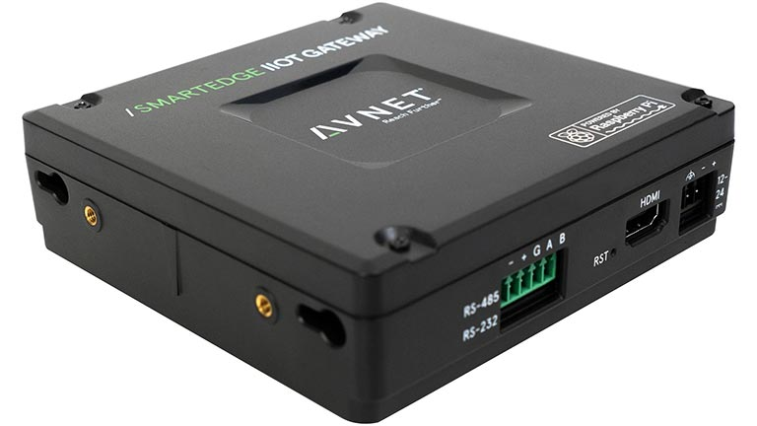
Figure 8 FEMS, Smart Edge Industrial IoT Gateway [2]
// TODO Explain necessity of and benefits of rs485 pins, communication, and digital IO

Evaluation of suitable switching devices

Circuit design

Software implementation
The Open-Source Energy Management System (OpenEMS) is used. OpenEMS is a modular platform for energy management applications. It was developed around the requirements of monitoring, controlling, and integrating energy storage with renewable energy sources, as well as complementary devices and services, like electric vehicle charging stations, heat-pumps, electrolysers, time-of-use electricity tariffs and more. OpenEMS is used in commercial products with a high level of reliability as well as scientific research projects. One of its main strengths is the flexibility to integrate with hardware from different vendors, subsystem software versions and Battery Management Systems (BMS) via a well-established abstraction model of digital twins.

Software architecture
OpenEMS is segregated into 3 logical components as shown in Figure 9 OpenEMS System Architecture[3] [3]:
- OpenEMS Edge runs on site, communicates with devices, and services, collects data, and executes control algorithms.
- OpenEMS Backend runs on a (cloud) server, connects the decentralized Edge systems, and provides aggregation, monitoring and control via the internet.
- OpenEMS UI provides a real-time user interface for web browsers and smartphones.

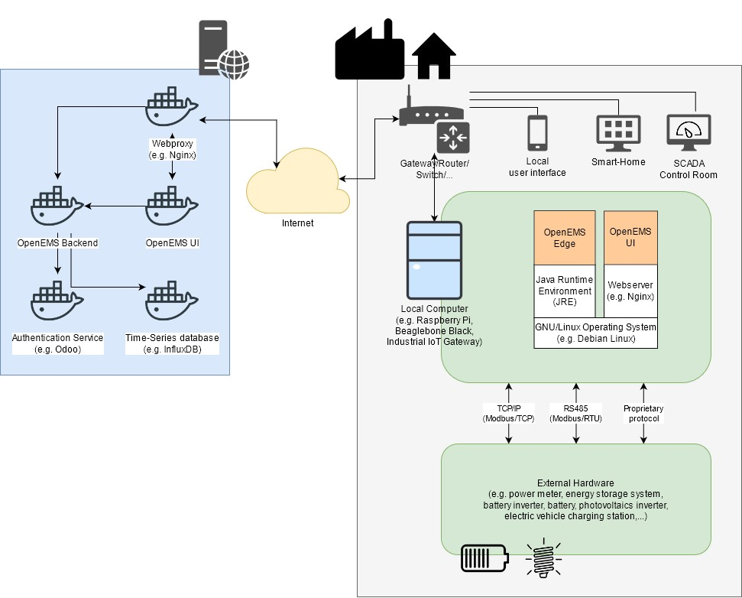
Figure SEQ Figure \* ARABIC 9 OpenEMS System Architecture CITATION Ope21 \l 1031 [3]
In this project specifically the OpenEMS Edge is used primarily. It borrows its name from "Edge Computing", the model for distributed computing that brings computation closer to the location where it is needed. In the case of OpenEMS Edge, this allows for local control of external hardware, independent of a connection to the internet. Furthermore, it enables quick data analytics, fast reaction rates and reduced network traffic.
OpenEMS Edge is implemented in the Java programming language and requires a Java Runtime Environment (JRE). This allows convenient development on a personal laptop on any operating system. For productive use, the software typically runs on an Industrial IoT Gateway or a development board like a Raspberry Pi with GNU/Linux Operating System.

Terminology
This section describes some of the core concepts and terms commonly used in OpenEMS Edge.

OpenEMS Component
A component is the fundamental building block in OpenEMS. Within the used OSGi which is a Java framework for developing and deploying modular software programs and libraries CITATION OSG21 \l 1031 [4], Java framework, an OpenEMS component represents a service with requirements and capabilities. As an example, an OpenEMS component can declare to have the capabilities of a BESS and as such represents the digital twin of a real device. A specific control algorithm for a BESS can be implemented as a separate OpenEMS Component that declares a requirement for a BESS. Using this metadata, these building blocks are wired together at runtime and form a very flexible system.
OSGi provides the capability to enable, modify or disable an OpenEMS Component at any time, without requiring a restart of the software. Re-wiring of the building blocks happens transparently in the background by the framework.
Every OpenEMS Component is identified by a unique ID, the “Component-ID”. In an ecosystem consisting of a couple of BESS, a power meter at the PCC, and a measured photovoltaic system, those Component-IDs can be represented as follows:
- “ess1” for the first BESS
- “ess2” for the second BESS
- “ess0” for a virtual BESS cluster Component that aggregates ess1 and ess2.
- “meter0” for the power meter at the PCC
- “meter1” for the measured photovoltaic system

Channel
Each OpenEMS component has a defined set of data points. These data points are called “Channels”. Each represents a single piece of information about a component. By definition, each channel has a unique ID, the “Channel-ID”, within its parent component.
Channels are defined by metadata like descriptive text, including access-mode (“read-only”, “read-write”, “write-only”), data type (“string”, “integer”, “float”, etc.), and unit of measure (“Watt”, “Volt”, “Degree Celsius”, etc.). It is up to the OpenEMS component to provide the input for its read-channels as well as triggering actions on write-channels.
In the example above, the BESS-Component continuously reads data, such as the current state of charge from the hardware's communication interface, e.g., via the Modbus protocol, and provides the data in its Channels.
Other Components in the system can then use the channel data for their application, e.g. as input for a control algorithm, to analyse it, store it locally or publish it via an application programming interface (API).

Channel Address
By combining the unique Component-ID and Channel-ID, each channel in the system can be addressed by a distinct “Channel Address” in the form “Component-ID/Channel-ID”. For example, the state of charge (“Soc”) of the first BESS (“ess1”) is identified by the unique channel address “ess1/Soc”.

Nature
Certain categories of devices and services provide the same kind of information (i.e., channels). To group these similar devices and services, OpenEMS defines “Natures” as sets of characteristics and attributes which need to be provided by each component that implements them. That is, a Nature extends a normal Java interface with channels. Examples of abstracting physical devices using Natures are:
- “SymmetricMeter” for power meters
- “SymmetricEss” for symmetric battery energy storage systems
- “Evcs” for electric vehicle charging stations.
OpenEMS components can declare their service capabilities and requirements as Natures. In this way, a control algorithm can simply declare a requirement for a controllable battery energy storage system (“ManagedSymmetricEss”) and will at runtime be wired with a service that provides this capability. The control algorithm does not need to know anything about the BESS's specific communication interface, protocol, or manufacturer.

Architecture
The OpenEMS Edge software architecture is carefully designed to abstract device communication and control algorithms in a way to provide maximum flexibility, predictability, and stability while simplifying the process of implementing new components. The scheme depicted in REF _Ref65510981 \h Figure 7 OpenEMS Edge Architecture shows the abstraction of hardware via Channels, Natures and Devices as well as the execution of control algorithms via Scheduler and Controllers.
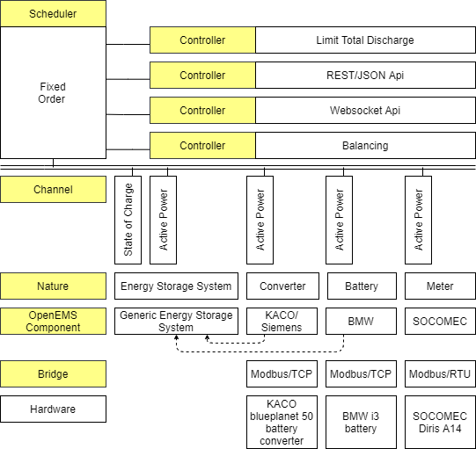
Figure SEQ Figure \* ARABIC 10 OpenEMS Edge Archiecture CITATION Ope211 \l 1031 [5]

Input-Process-Output
OpenEMS Edge is built around the well-known input-process-output (IPO) model, which defines the internal execution cycle (see REF _Ref65515869 \h Figure 11 IPO model).
- Input: During the input phase all relevant information – e.g., the current 'state of charge' of a battery – is collected and provided as a process image. This process image is guaranteed to never change during the cycle.
- Process: The process phase runs algorithms and tasks based on the process image – e.g., an algorithm uses the 'state of charge' information to evaluate whether a digital output should be turned on.
- Output: The output phase takes the results from the process phase and applies it – e.g., it turns the digital output on or off.
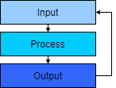
Figure SEQ Figure \* ARABIC 11 IPO model CITATION Ope211 \l 1031 [5]
// Show current architecture for on-grid systems (BatteryInverter + Battery + Generic-ESS); Extend with new Battery-Inverter Nature for off-grid; Generic-ESS for Off-Grid, State-Machine for Controller that does the switching.

Cycle
The IPO model in OpenEMS Edge is executed in a Cycle – implemented by the Cycle component ( REF _Ref65516457 \h Figure 12 OpenEMS Edge Cycle CITATION Ope211 \l 1031 [5][5]). It handles the setting of a process image in the input phase and executes the controllers in the process phase. Furthermore, it emits Cycle Events that can be used in other components to synchronize with the cycle.
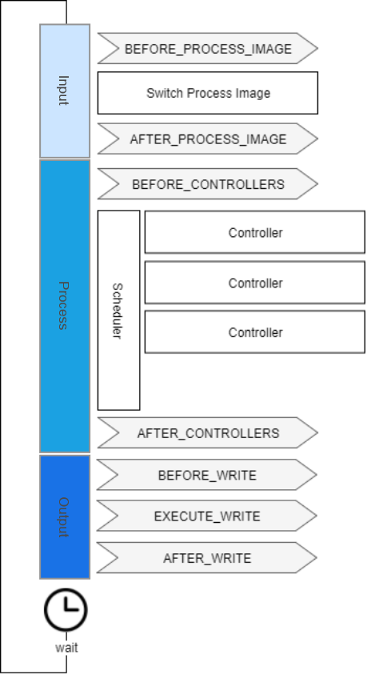
Figure SEQ Figure \* ARABIC 12 OpenEMS Edge Cycle CITATION Ope211 \l 1031 [5]

Controller
Controllers are consumers of Channel data and hold the actual business logic, e.g., the control algorithm that evaluates input data and defines setpoints for the controlled hardware. Examples for controllers are:
- “Controller.Ess.LimitTotalDischarge” maintains a minimum battery level
- “Controller.Backend.Api” connects to the OpenEMS Backend server
- “Controller.Rest.Api” provides a JSON/REST-Api for external
- “Controller.Debug.Log” logs regular system status messages to the standard output
- “Controller.Ess.PeakShaving” charges or discharges a BESS in order to cut power peaks at the PCC
- “Controller.Ess.Balancing” charges or discharges a BESS in order to optimize self-consumption from a local photovoltaics system
Ideally controller implementations follow the KISS (Keep It Simple Stupid) principle, which means that they carry out only one specific, encapsulated task. This approach allows very flexible system architectures and avoids duplicated code. For example, both “Ess.PeakShaving” and “Ess.Balancing” controllers do not need to repeat any logic for keeping the battery at a safe state, as this is what the “Ess.LimitTotalDischarge” controller is responsible for doing.
As can be seen above, controllers are not necessarily restricted to control algorithms. Even northbound connections to a backend server or SCADA system and alike are implemented as Controllers. This assures for any setpoint request by an external system being embedded in the local prioritization system and naturally restricted by higher-priority controllers. Example: an external request to discharge the battery will be limited by the “Ess.LimitTotalDischarge” controller just like any other internal control algorithm.
Controllers are executed regularly e.g., once per second (see “Cycle” below”). The scheduler mechanism sets the priority in which the controllers are executed.

Scheduler
Typically, more than one controller is active in OpenEMS Edge simultaneously, which makes it necessary to prioritise their execution.
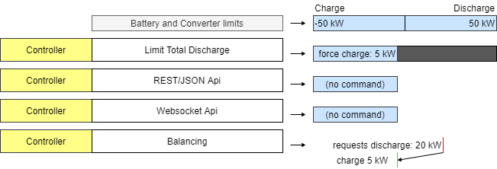
Figure SEQ Figure \* ARABIC 13 Prioritisation of BESS power setpoints
REF _Ref65515213 \h Figure 11 Prioritisation of BESS power setpoints shows, how the interval of possible solutions is reduced by sequentially executed controllers. In the example the initial BESS limits from battery and converter allow charging and discharging with 50 kW. The “Limit Total Discharge” controller then adds a constraint to force charge the BESS, i.e., enforcing a setpoint that is smaller than -5 kW. No further limitations are applied by the Api controllers. The Balancing controller then requests discharging the BESS with 20 kW but is forced to fulfil the constraints. Eventually the BESS gets force-charged with 5 kW.
The scheduler in OpenEMS Edge handles this prioritization and sequential execution of controllers. In the example of controlling a BESS, a separate “Ess.Power” component synchronizes with the IPO cycle and manages feasible solutions via a linear equation system that allows constraints on three-phase or single-phase setpoints for active and reactive power. It is also used for optimizing distribution of setpoints in the case of multiple BESS.

Fault Tolerance
An energy system architecture as depicted in REF _Ref65510981 \h Figure 10 OpenEMS Edge Architecture is complex: connected to multiple hardware devices – batteries, converters, meters, and others – and an operating system and other software components. All these elements are possible sources of errors. Because of this, measures are implemented in OpenEMS to improve fault tolerance:
First, developers need to be aware, that every channel value, while it will never change within a cycle, it could always be ‘undefined’ or ‘null’, e.g., because there is no communication (yet) with the external hardware device or service. Therefore, the programming API for accessing a channel value requires an explicit declaration of what should be done in that case. It provides the following methods to get the actual value:
- public T getOrError() throws InvalidValueException;
- public T orElse(T alternativeValue);
Second, if there happens any error within the complex system architecture, the software must try to recover automatically without any human dependence, e.g., pressing reset or power cycling. If a system can recover from an error, then the device is termed as good. This approach is widely known as a Watchdog timer and requires each architectural layer to continuously report to its superior layer about its running status. The Watchdog consists of three mechanisms:
- A timer, which counts the duration since last reset.
- The act of resetting the timer – also known as “kicking the watchdog”.
- An action that is eventually activated when the timer exceeds a maximum duration.
The OpenEMS java executable, reports to the operating systems on every cycle that it is still running, by notifying the ‘systemd init process’. Systemd is recommended to be configured in a way, that it accepts watchdog resets (see “Deploy OpenEMS Edge” documentation) and eventually reboots the entire EMS hardware when an architectural layer fails.
Apart from that, many external hardware devices implement watchdog functionalities that require the EMS to constantly reset a remote timer via a communication protocol like Modbus, to announce that the EMS is still in control. These functions are implemented within each OpenEMS component that represents a hardware device individually.

Adaptive User Interface
The OpenEMS UI is the standard user interface for OpenEMS. It uses the EdgeConfig to adapt its visualisation in accordance with the actual configuration. REF _Ref65514464 \h Figure 11 OpenEMS UI Live view visualizes the “Live view” of OpenEMS UI. It shows Storage System, Production and Grid because corresponding OpenEMS Components are listed in the EdgeConfig.
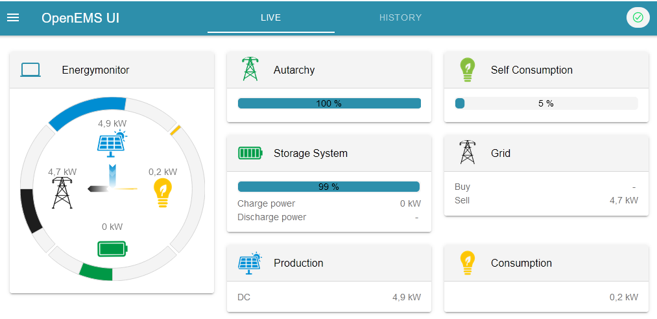
Figure SEQ Figure \* ARABIC 14 OpenEMS UI Live view
OpenEMS UI also provides a way to instantiate an OpenEMS Component from a factory by providing configuration parameters. The “Settings | Install Components” view shown in REF _Ref65514549 \h Figure 12 OpenEMS UI List of factories from EdgeConfig and generates dynamic configuration forms per factory ( REF _Ref65514593 \h Figure 13 OpenEMS UI Setup Bridge Modbus/TCP component).
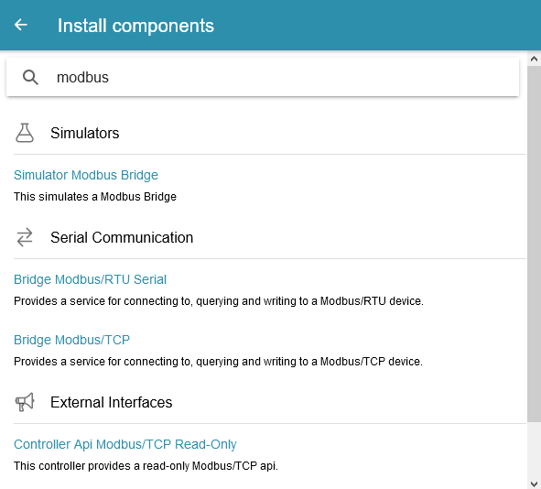
Figure SEQ Figure \* ARABIC 15 OpenEMS UI List of factories
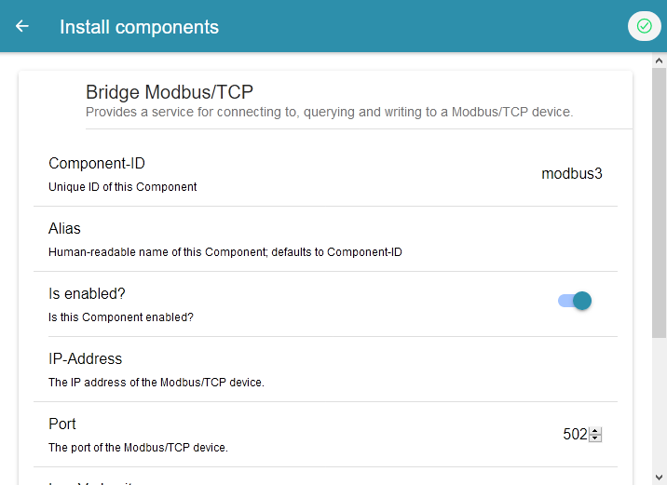
Figure SEQ Figure \* ARABIC 16 OpenEMS UI Setup Bridge Modbus/TCP component

Apache Felix Web Console
The Java/OSGi framework provides the Apache Felix Web Console as a standard tool to adjust the configuration of any OSGi based software like OpenEMS Edge (see REF _Ref65514639 \h Figure 14 Apache Felix Web Console). It internally uses a similar approach to the EdgeConfig, without OpenEMS specific extensions like channels information.

Figure SEQ Figure \* ARABIC 17 Apache Felix Web Console

//TODO Reading and writing of the registers

Software implementation
This

//TODO Implementation of the inverter in OpenEMS

//TODO Important methods for controlling the inverter

//TODO Establishment of data monitoring

//TODO Load and run the OpenEMS on the FEMS

//TODO Basic Apache Felix web console configurations

// TODO Configuration for the OpenEMS backend and OpenEMS UI

//TODO Other controller configurations

Evaluation and test

Summary / conclusion / outlook

//TODO Interpretation of the measurement results

//TODO Current limitation at the state of charge limits, cell voltages?

//TODO Balancing Symmetric Controller ?

References

BIBLIOGRAPHY
[1] | „Modbus Protocol,“ [Online]. Available: https://www.modbustools.com/modbus.html. [Zugriff am 23 02 2021].
[2] | „avnet,“ [Online]. Available: https://www.element14.com/community/docs/DOC-92862.
[3] | "OpenEMS documentation," [Online]. Available: https://openems.github.io/openems.io/openems/latest/introduction.html. [Accessed 21 January 2021].
[4] | „OSGI,“ 02 28 2021. [Online]. Available: https://www.osgi.org.
[5] | "OpenEMS documentation - edge architecture," [Online]. Available: https://openems.github.io/openems.io/openems/latest/edge/architecture.html. [Accessed 28 02 2021].

- FEMS hardware specifiations
